Computer networks

**Lab activity – 1 2**

**Name :** N.V.M.Sumanth

**Reg no :** 192111449

**Faculty :** Dr. S. Ramesh

**Course code :** CSA0786 computer networks for wanet applications

**Lab activity :12**

**Question - Smart Garden in Cisco Packet Tracer**

**Step 1 : Take one server, wireless router, laptop, water level meter, sprinkler**

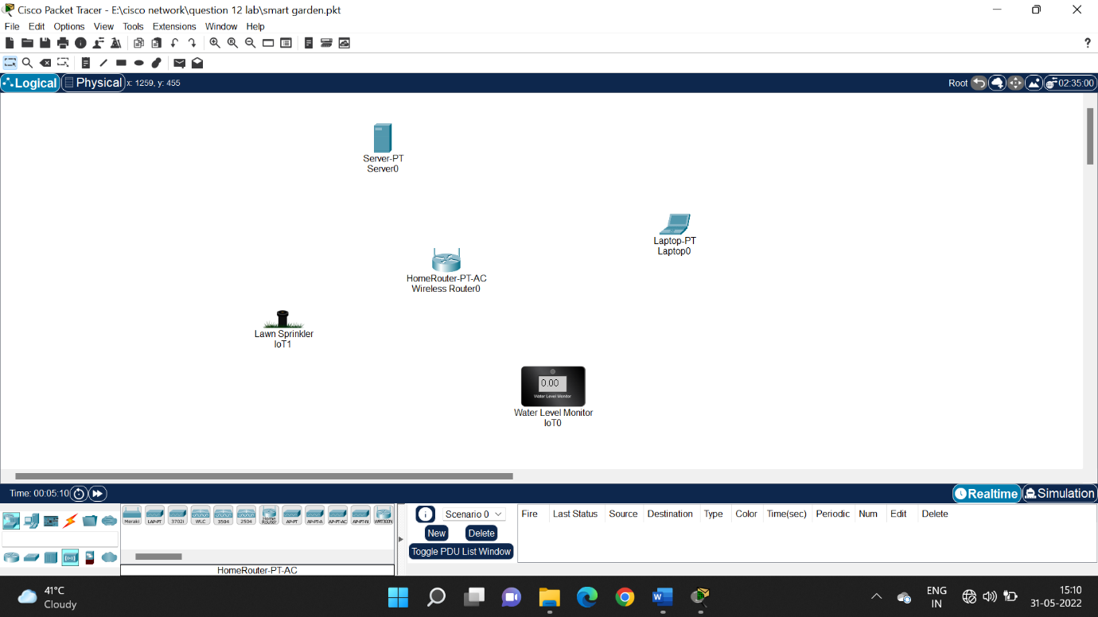

**Step 2 : configure IP address to server**

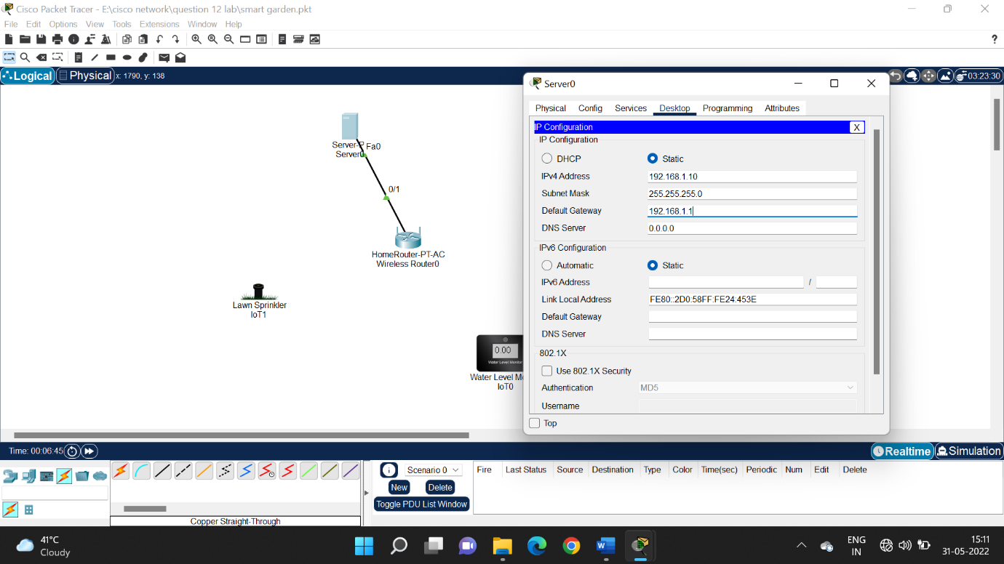

**Step 3 : configure IP address in router setup**

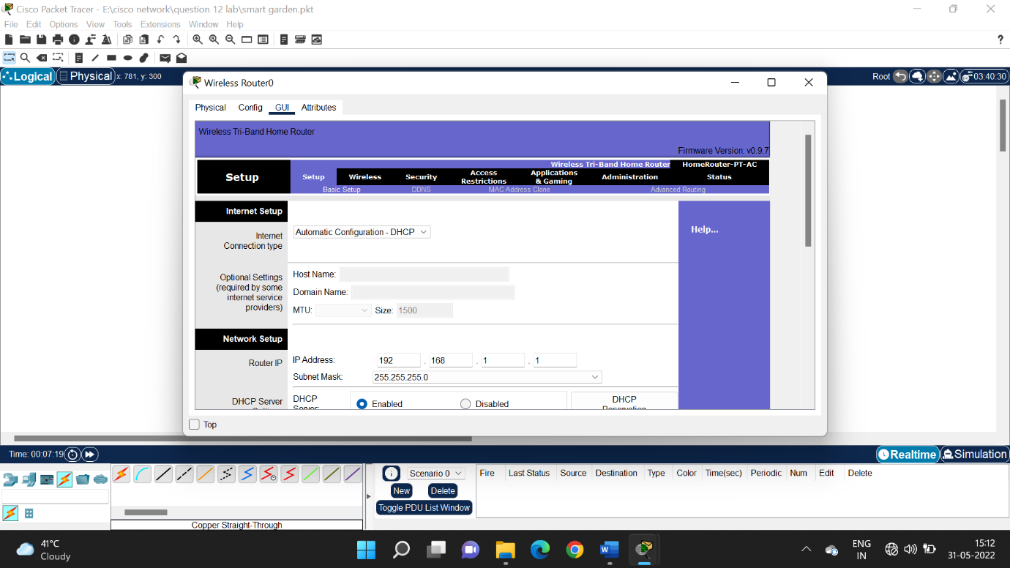

**Step 4 : configure Ip address and security phase in wireless**

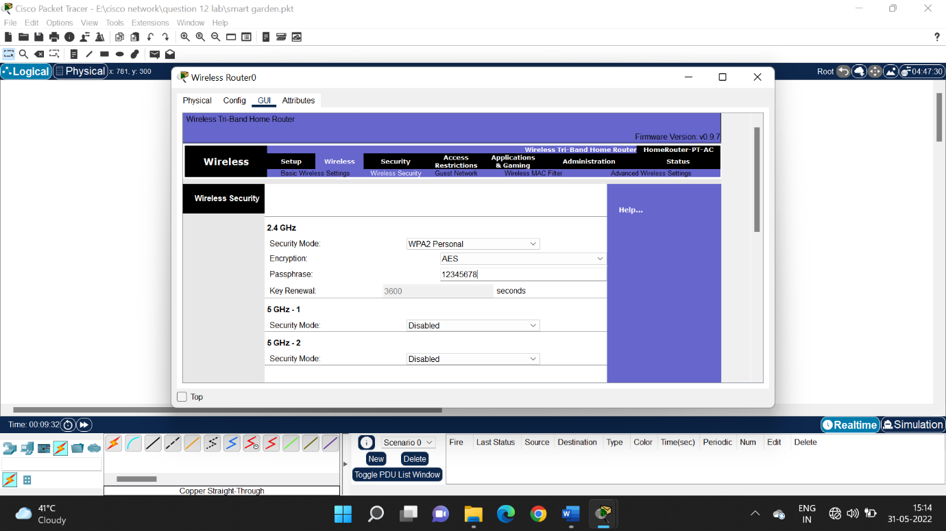

**Step 5 : switch off laptop and change module to connect the devices**

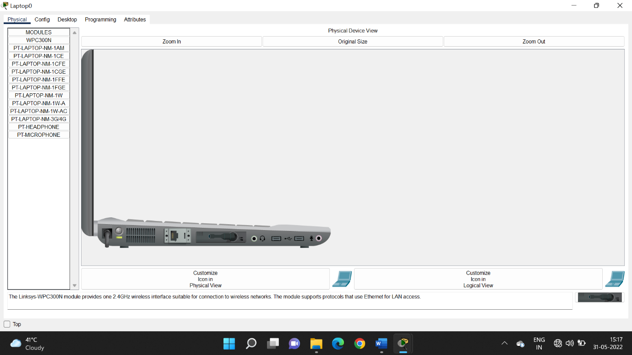

**Step 6 : change network adapter in i/0 configuration of spriklers and waterlevel meter**

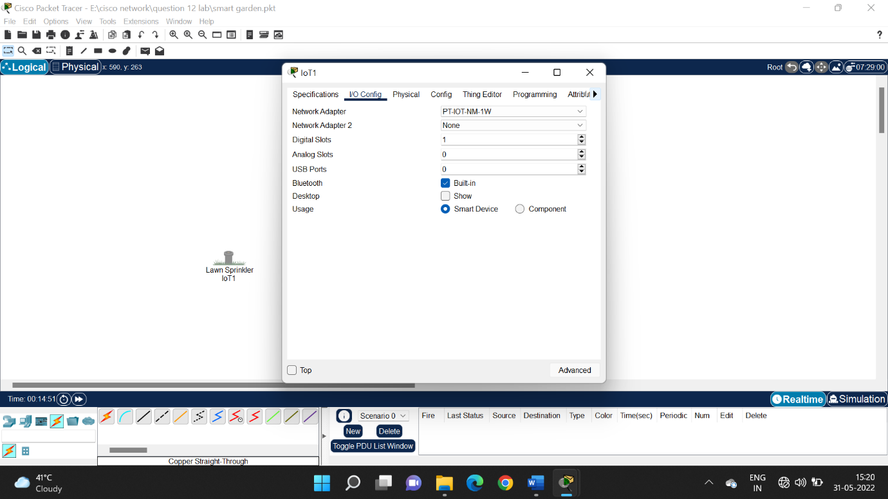

**Step 7 : Give SSID in configuration and select wpa2 – psk and enter passphrase**

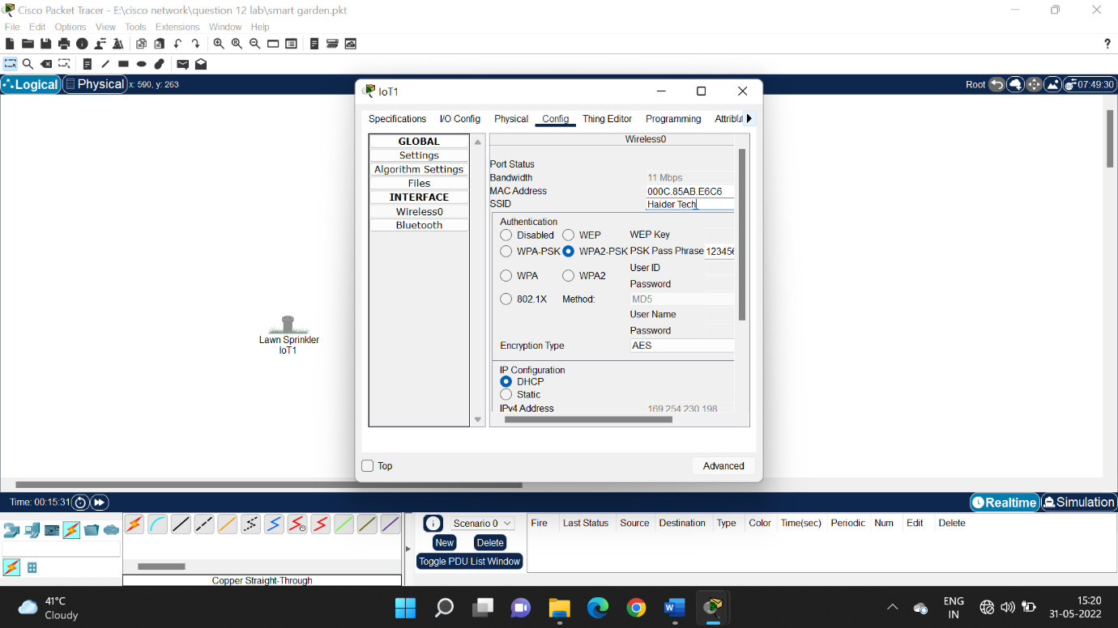

**Step 8 : check all the devices are connected**

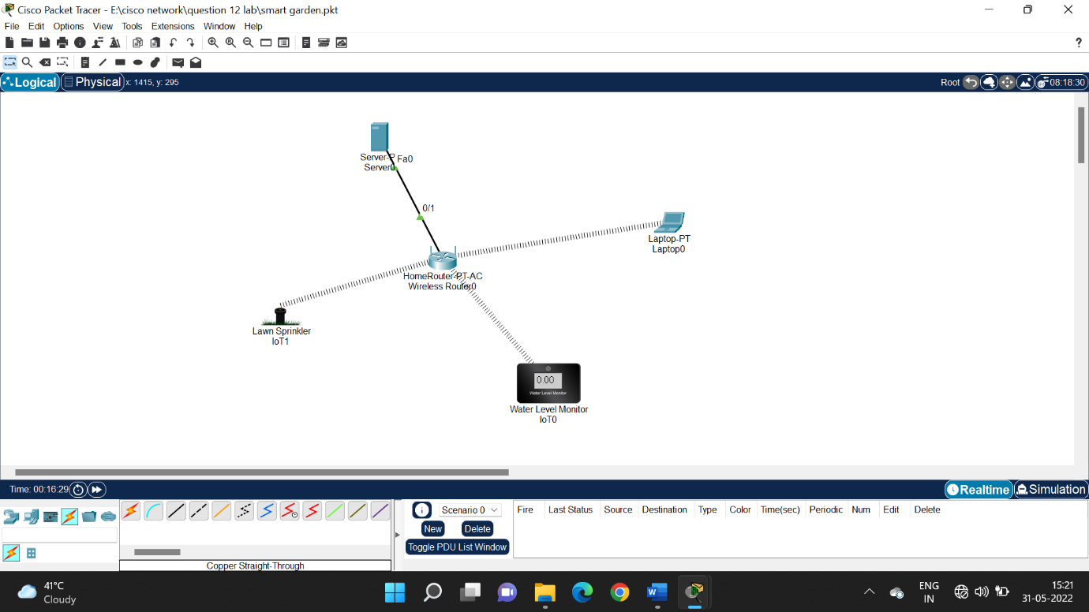

**Step 9 : connect wirelessly by configuring username and passcode in both the devices.**

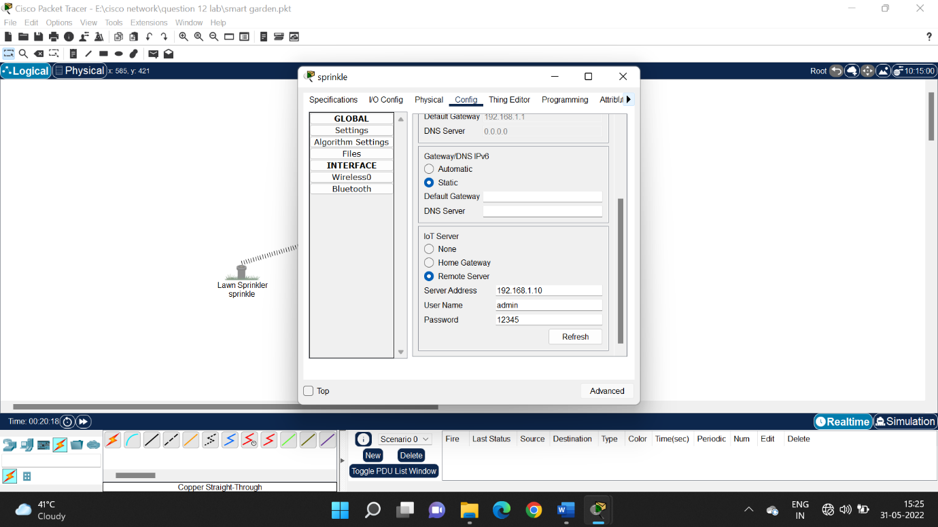

**Step 10 : run the IP address in web browser and register the account**

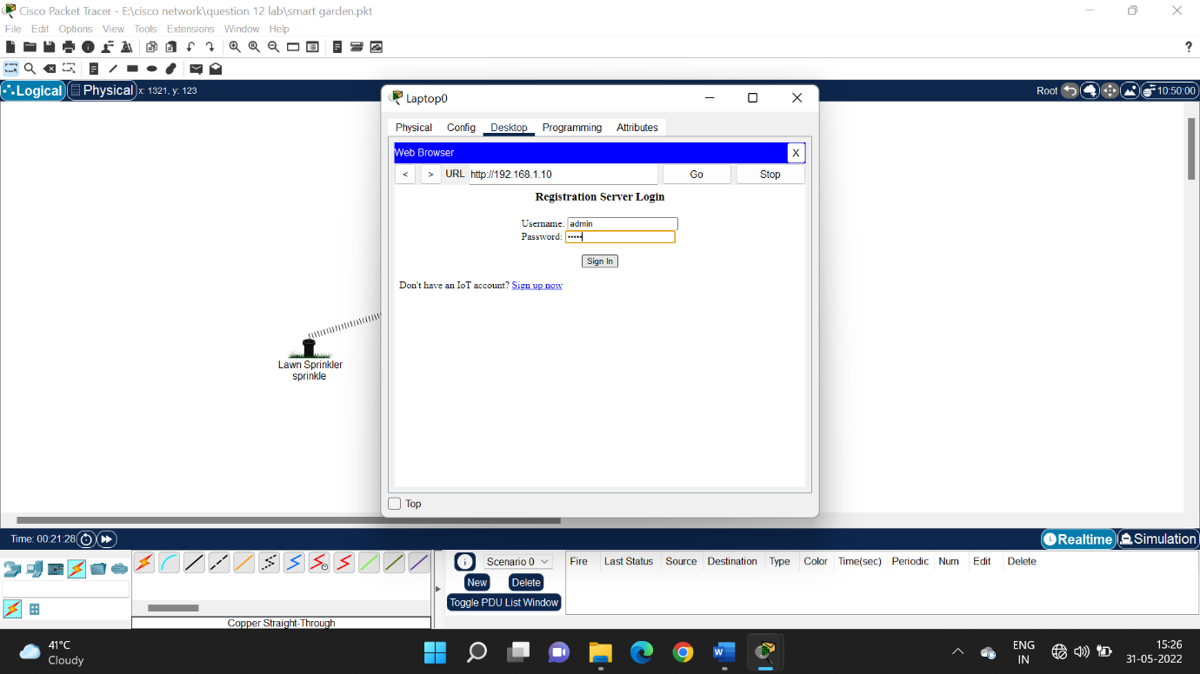

**Step 11 : control the devices wirelessly**

